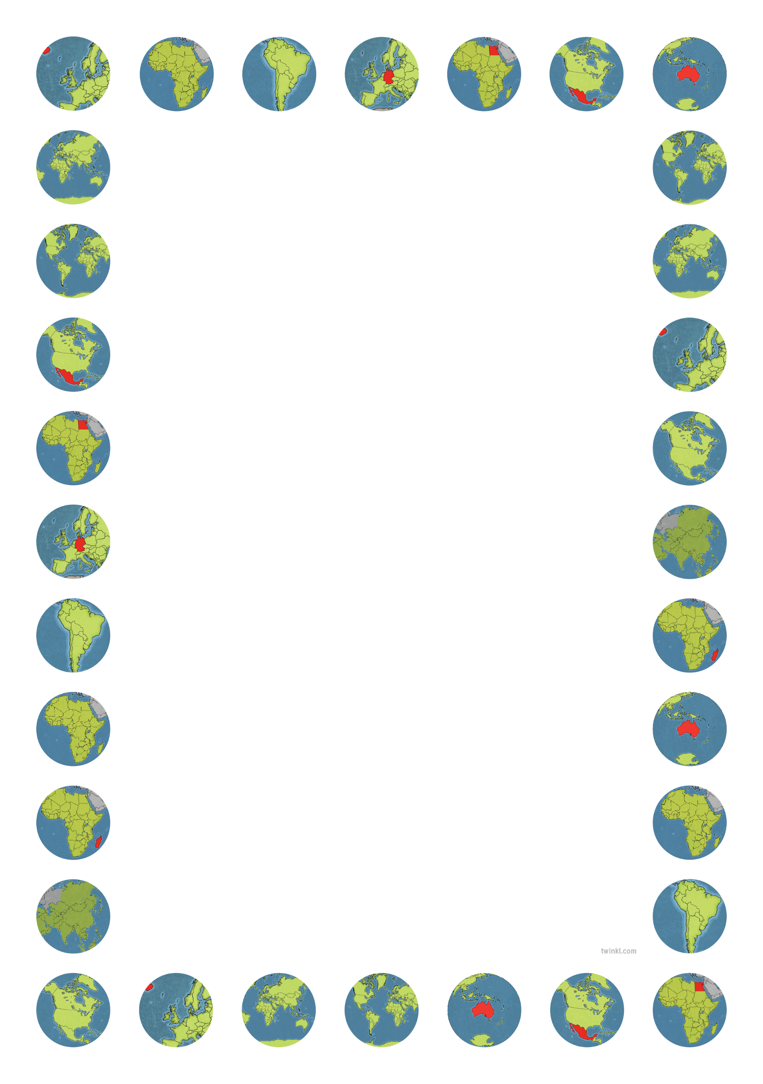

|  |  |  |  |
| --- | --- | --- | --- |
| Corfe Class - Half-Termly Plan - Summer 2 – Our Planet  Welcome to what is always a very busy, fun and hopefully sunny half term in Corfe Class. This term is always a busy one with sports day, our whole class farm trip and lots of class transition sessions as we look forward to September. This half term all Corfe class children will enjoy some transition sessions on Tuesday afternoons where they will spend an hour each week with their new classes.  There is also the whole school sponsored colour run to look forward to. | | | |
| Maths  In Maths we continue to follow both the Mastery maths programme and the White Rose maths program.  The Reception children will be concentrating on securing their knowledge of number bonds to 10 as well as counting up to and beyond 20.  We are also still working on our understanding of odd and even numbers, doubles and a little bit more on subtraction.  The Year One children will continue to develop their understanding of grouping and sharing, counting in 2s,5s and 10s as well as understanding equal groups and moving onto simple fractions.  They will also continue to secure their number bonds to 20 and count up to and beyond 100. | English  In English our topic will lead us to focus the first few weeks on the book ‘Somebody Swallowed Stanley’  We will concentrate on refining our developing writing skills; using full stops, capital letters and finger spaces to make our reading easy to read. We will concentrate on re-reading our writing to make sure it makes sense as well as developing our writing stamina to write longer texts including stories of our own.  We will end the half term focusing on more informative texts and learning about a wide range of ways we can help to support our environment and limit our environmental impact.  We will be looking at other story and information books along the way including ‘Harry Saves The Ocean’ and ‘Earth Matters’ as well as information texts about different creatures that live in the sea. | Phonics & Reading  All children in Corfe will continue with their daily phonics lessons as well as their three reads a week in our group reading sessions before bringing their reading book home to share with you over the weekend.  Please continue to support your children by reading their school reading book at the weekends and sharing the library book they bring home.  Also please help them to keep up with the learning by completing the weekly homework sheets that are sent home at the beginning of the term.  If you are interested in becoming a reading volunteer – please speak to Miss Ives. You will need to be able to commit to one afternoon a week to hear children read their school reading books. | Science & Topic  Our Science learning will begin by exploring the differences between the seasons and weather patterns by focussing in on Spring moving into Summer. We will also be finding some time to complete some investigations where we will develop our skills in predicting, observing, discussing and recording our findings using simple tables.  In topic this term we will be exploring different artists, such as Kandinsky, Goldsworthy and Georgia O’Keeffe. We will be using a variety of materials as well as creating large pieces of art outside.  We will also be creating Rock Pools so please send in some resources to help.  Linked to our English we will also be thinking about pollution, recycling and where our rubbish goes. |