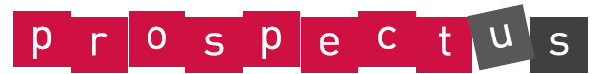
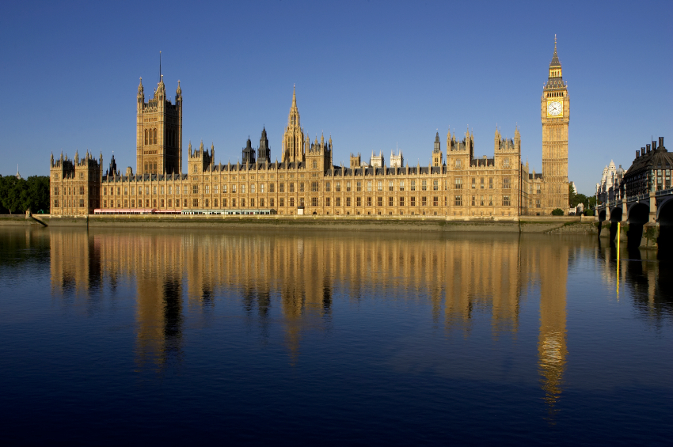

Yes Minister! Year 6

Essential Knowledge

By the end of this unit children will know...

- Use different sources of research e.g. books, newspapers, Internet to find out about parliament.
- Describe and understand the difference between rules and laws and how they are made and enforced.
- Describe and understand the role of MPs.
- Describe and understand different form of government across the world.
- Understand the difference between different political parties.
- Use their understanding of political parties, rules and laws to create their own political manifestos to be judged by their peers.

Share manifestos with another year group e.g. Y5 and then ask Y6 to vote so that they can see who the winning party is.
Possible School Performances/Assemblies.

Celebrate

Energise
Keep an eye on the news – react to current events, how do MPs react?
Children are to form their own political parties and manifesto.
Children to consider “If I ruled the World” (song from Pickwick the musical) or “I have a dream” (Martin Luther King).

Explore

Children are to research and understand different forms of government and the role of governments.
Children are to look at the role of voting and the role of MPs.
Children are to understand the difference between rules and laws and how they are made.
Children are to understand the difference between different political parties.

Launch

Visits and experiences:
What are the Houses of Parliament?
http://www.parliament.uk/education/

Yes Minister! Year 6: Theme Content

Core Subjects: Links to theme

Personal Development

Foundation Subjects

English
- Write a letter to MP regarding a local or national issue.
- Find out about the Suffragettes and write an informal letter
- Write instructions about how to vote
- Debate whether voting should be compulsory in the UK

Mathematics
- N/A

Science
- Forces

Spiritual
Social
Art and Design and Design Technology

History, Geography and Citizenship

Art:
- Poster campaign for a political party.
- Houses of parliament artwork based on piece by Claude Monet.
Design Technology:
• Design and make a ’guy’ of a famous figure within popular culture‘.

Music, Languages and Physical Education

Music:
- Create a new song based around the song ‘If I ruled the world’.

History:
- To trace the origins of the parliamentary system.
- To evaluate primary and secondary sources to find out about Guy Fawkes and the gunpowder plot.
Geography:
- Map Skills – Locating different forms of government across the world.
- To look at the location of constituencies within the UK.
- To look at the political party map from the last general election.
Citizenship:
- Understand the political and voting systems of the United Kingdom.

Computing

- Compare laws and rules within the legal system to laws and rules within religions. How much should religious law be respected and obeyed e.g. Shariah law?

Moral
- To look at the role of government to set moral rules and laws within our society, how they are enforced and what it would be like if they were not enforced.

- Children will work collaboratively.
- To look at rules and laws within our society, how they are enforced and what it would be like if they were not enforced.

Cultural
- How do we adapt to change in our lives placed on us by new government?
- What is life like under different political systems?

Yes Minister! Year 6: Links to National Curriculum Framework

Foundation Subjects

Core Subjects:

Art and Design:
- Give details about the style of some notable artists, artisan and designers.
- Show how the work of those studied was influential in both society and to other artists.
- Create original pieces that show a range of influences and styles.
- Build up layers of colours.
- Use a variety of techniques to add interesting effects (e.g. reflections, shadows, direction of sunlight).
Design Technology:
- Cut materials with precision and refine the finish with appropriate tools.
- Show an understanding of the qualities of materials to choose appropriate tools to cut and shape.

Music, Languages and Physical Education

History, Geography and Citizenship

- Create songs with verses and a chorus.
- Create rhythmic patterns with an awareness of timbre and duration.
- Thoughtfully select elements for a piece in order to gain a desired effect.

English
- Ask questions to improve understanding.
- Retrieve and record information from non-fiction.
- Use adventurous and sophisticated vocabulary.
- Note, develop and research ideas.
- Choose the appropriate form of writing using the main features identified in reading.
- Ask questions and make suggestions to take an active part in discussions.
- Debate, using relevant details to support points.
- Offer alternative explanations when others don’t understand.
- Identify the audience for writing.
- Guide the reader by using a range of organizational devices, including a range of connectives.

Mathematics

Computing

History:
- Use sources of evidence to deduce information about the past.
- Select suitable sources of evidence, giving reasons for choices.
- Gain and deploy a historically grounded understanding of abstract terms such as ‘empire’, ‘civilisation’, ‘parliament’ and ‘peasantry’.
- Seek out and analyse a wide range of evidence in order to justify claims about the past.
Geography:
- Collect and analyse statistics and other information in order to draw conclusions about locations.
- Name and locate some of the countries of the world and their identifying human and physical characteristics.
- Describe how some locations around the world are changing and explain some of the reasons for change.
- Describe and understand key aspects of human geography including: settlements, land use, economic activity.
Citizenship (From KS3 Objectives):
- Understand the development of the political system of democratic government in the United Kingdom, including the roles of citizens, parliament and the Monarch.
- Understand the operation of parliament, including voting and elections, and the role of political parties.
- Understand the functions and use of money, the importance and practice of budgeting, and managing risk.

Science

Art and Design and Design Technology

Yes Minister! Year 6: Assessment Opportunities/Tasks within theme

Core Subjects

Foundation Subjects

Science
English
- Children create a dictionary of parliamentary terms.
- Children demonstrate knowledge and understanding of the suffragette cause through their letters written in role from the point of view of a suffragette.
- Children write a balanced argument for and against the idea of electronic voting.
- Children write an argument based on one side of the issue ‘Should the age for voting be lowered?’
- Children write in role as an MP—can they adopt a formal tone.

Mathematics
Computing

Art and Design and Design Technology

History, Geography and Citizenship

History:
- Children use a variety of sources of evidence to research the story behind ‘the Gunpowder Plot’. Can the children evaluate the effectiveness of the different sources of information?
Geography:
- Children can name different types of government e.g. democracy, dictatorship, monarchy etc. and can identify countries around the world where these types of government exist.
- Children identify environmental issues within the local area.
Citizenship (From KS3 Objectives):
- Through their work writing in role as an MP and also through their factfiles about the political parties, children demonstrate a clear knowledge of the term democracy and can identify the voting system and why it is important to vote.

Art and Design:
- Children demonstrate the ability to blend colour and to create effects such as reflection and shadows through their artwork based on Monet’s ‘Houses of Parliament’.
Design Technology:
- Children demonstrate ability to cut and sew accurately through their making of the guy.

Music, Languages and Physical Education

- Children can compose and write a song based on the song ‘If I ruled the World’.

