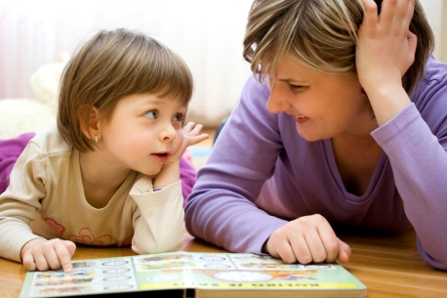

smarter Help Better Future

Most parents want to know how to help their child do the best they can at school. Some children do well in school, some children do less well. There can be many reasons for this, but a very important one is that learning doesn’t only happen at school. Parents play a really important part in their children’s achievement.
Did you know that you can boost your child’s learning by up to 25% by providing the right support.

Supporting your child can be both enjoyable and productive. If done in the right way, it can bring about amazing results in your child’s learning.
Research has come up with some very surprising findings. The main one being that it is parents, not schools, which make the biggest difference to how well pupils achieve in their learning. When ‘good’ schools were compared with good parenting, it was found that adults who understand the curriculum and support their children at home could boost children’s learning by 25% more than good schooling alone.
So what can you do?

When children are younger the most important support that parents can give their child is to talk more. Good speakers become good readers and writers. Conversation is the key to all learning.
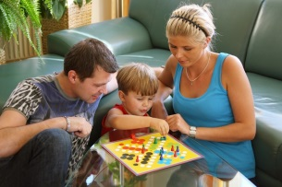
Have quiet times with the TV/music turned off and when you just talk to your child. Try to make this at a time when both of you are relaxed. Listen carefully to you child. Show them you value what they have to say.
Why not try:
- playing board games and card games. These encourage speaking/questioning/turn taking and having fun.
- Reading to your child daily helps them to enjoy books. It helps with their listening skills and language development.
- Sharing books. Talk about what is happening to the characters in the stories. What they are doing and how they are feeling. Talk about where the story is taking place. Is it somewhere familiar or somewhere strange? Encourage your child to think about what might happen next.
Reading support

When children bring home their own reading books, making the time for them to read to you every day can make a huge difference to their reading progress, even if you can only manage 5 – 10 minutes. Use the same techniques to talk about the books, as described in the sharing books section above.
visual perception and hand eye coordination support
maths support
Even if you don’t feel confident with maths yourself, you can still make a huge difference to your child’s numeracy confidence and ability. Helping your child feel positive about maths is really important and it’s something every parent can do.
It is really important thing is to give your child the opportunity to use and talk about maths every day. This will help them to develop lifelong skills. Children learn maths best through activities and tasks.
Here are just some of the things you can do together:
- Sort items into groups
- Talk about the shape and size of objects
- Compare bigger, biggest, smaller, smallest, etc
- Use maths language as above, as well as before/after, less/more, first, second, last, under, over, between etc.
- Count items such as toys in a box or teddy bears or the steps/stairs you climb
- Practise counting backwards too
Visual perception plays a very important part in learning to read, write and do maths. It is all about how our eyes and brain work together to support our learning. Hand eye coordination is essential for writing.
Perceptual skills start to develop in the first weeks of life and continue until children reach their teenage years. Sometimes visual perceptual skills need to be better developed to give children the best chance of learning. If children are struggling in school, it might be because they need extra help to develop these skills. Difficulty with these skills is not obvious and no one may know about them until school work starts to suffer. With reading for example, children may find it difficult to read words because they read letters the wrong way round or back to front. The same problems can occur when spelling. In maths, these skills can affect how easily children can read symbols and understand number sentences.
There are lots of activities children can practise at home to make visual perceptual skills better. As with all learning, constant practice – little and often is the key to improvement.
- Activity books contain many different activities to improve these skills – mazes, dot-to-dot, odd one out & spot the difference games.
- Craft activities – tracing, colouring, stencils, painting by numbers, cutting and sticking. Origami & folding paper games (e.g. paper aeroplanes). Complete unfinished pictures (the other half for example) & copy pictures.
- Board games and jigsaws, Simon Says, I Spy, word searches, ‘Where’s Wally’, Lego and construction toys.
As well as these indoor family activities, old fashioned physical activity also helps reading and writing! Playground equipment, ball games, hopping, riding a scooter, riding a bike, skipping and jumping.
If you would like more information about anything in particular, someone in school will be happy to talk to you. We will also be putting information about supporting different subjects and different age groups onto our website. The most important thing about any learning is that it should be relaxed and enjoyable. Make it a natural part of your day rather than a chore!

