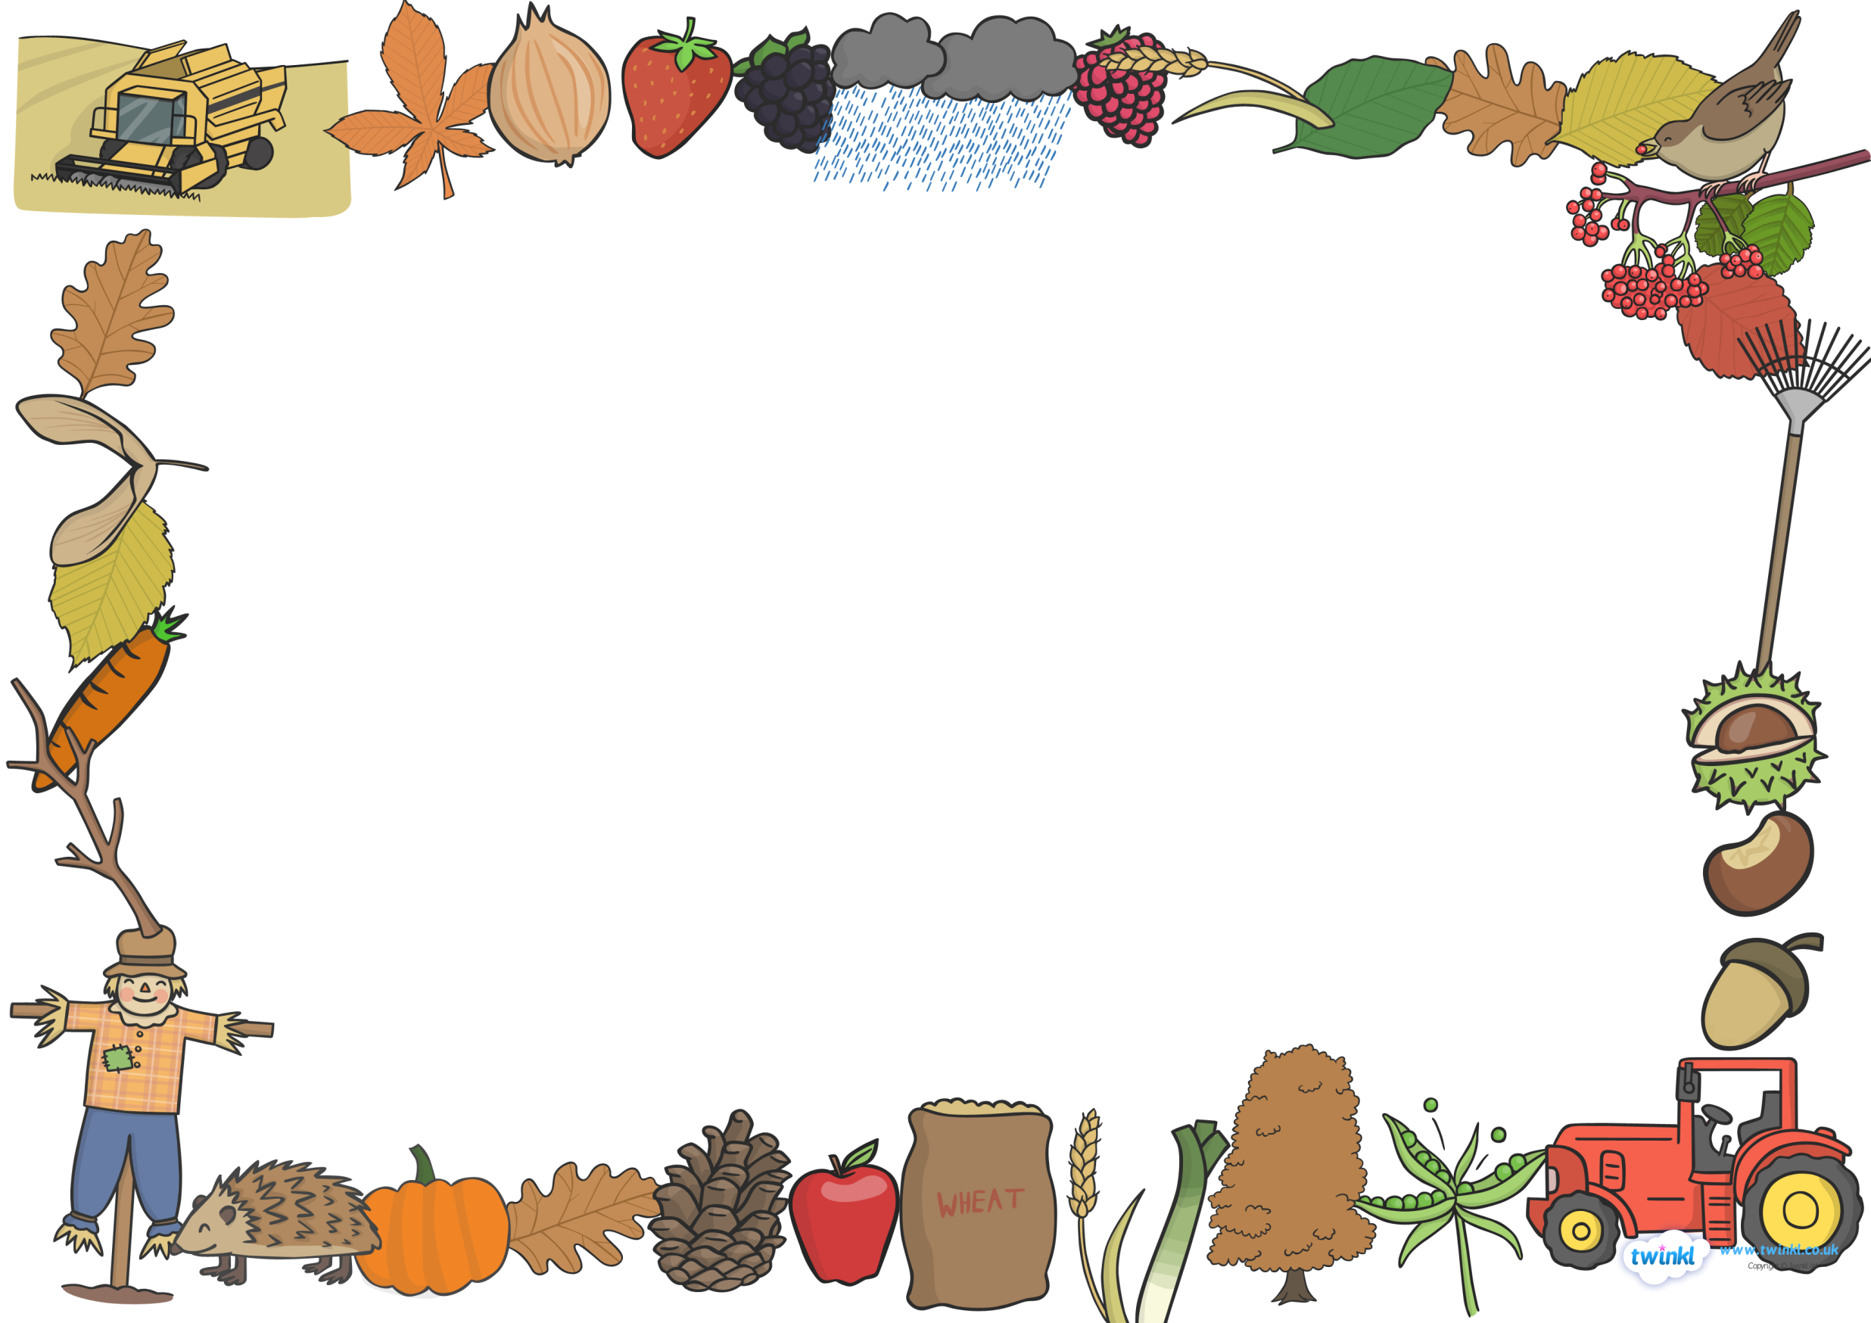

Corfe Class – Autumn Term 2 2026 - Let’s Celebrate!
Autumn, Weather, Festivals and Christmas!

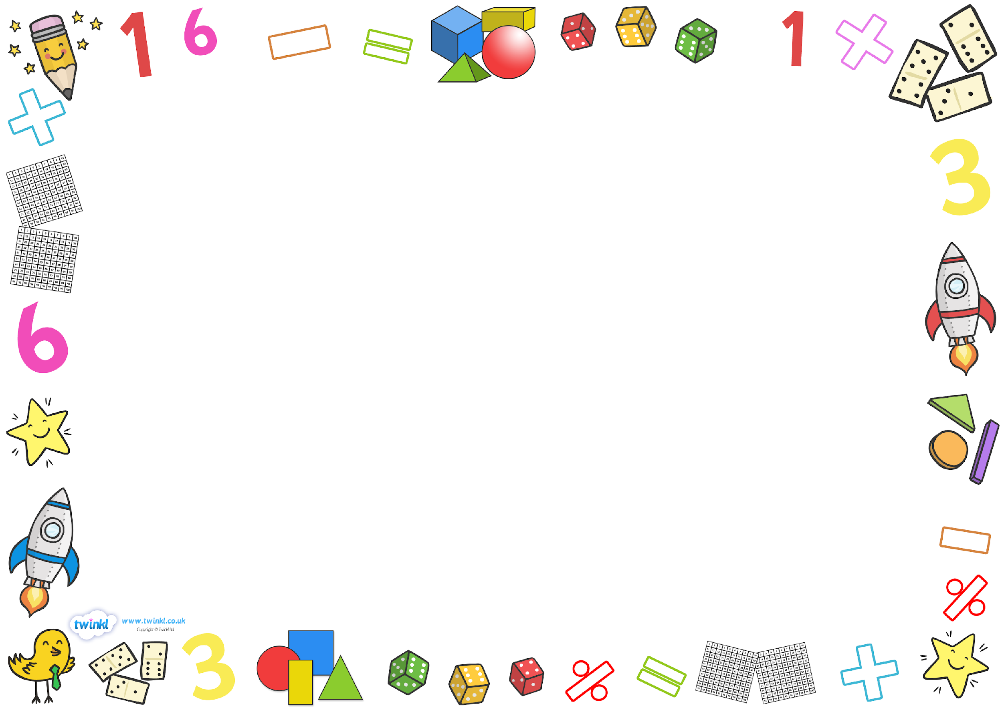
Welcome Back!
We hope you have had a good rest and are ready for the term ahead and the lead up to Christmas!! This half term our topic overviews have been combined to include both Reception and Year 1 activities that will take place in Corfe Class. Phonics will continue to be taught in separately in year groups as will our maths sessions. These will continue to be taught in year groups following the Mastery Maths and White Rose Programmes.
Please see the accompanying Maths information sheet to see what aspects of maths learning your child will be focusing on this half term.
All our learning in Corfe will continue to be underpinned by the development of communication (speaking and listening skills) as well as personal, social and emotional development and wellbeing. We have been working on upskilling the children with the tools they need to speak kindly to one another as well as embedding our school values and helping the children to make good choices with regards to their learning behaviours and their social behaviours to each other. We encourage them to listen to each other’s needs and questions and respond accordingly.
For the first few weeks of term our topic is ‘Autumn’.
In Science, we be thinking about changes in the weather and this term, will have the opportunity to plant some bulbs and talk about what they need to grow.
In RE we will be thinking about ‘Why Christians do Nativity Plays at Christmas time’ so as well as actually taking part in our own Christmas Nativity (details to follow) we will also be learning about some of the ideas around the birth of Jesus.
There are also some different festivals and special times that happen around Autumn that we will be thinking about too, such as Bonfire Night and Remembrance Day. We will touch on these in our Topic sessions on Tuesday afternoons before we launch into the lead up to Christmas and all the excitement that this brings!
As the nights draw in, we will also be thinking about how to keep ourselves safe in the dark. To help us with this, we will be reading lots of different stories with autumnal themes including Christopher Pumpkin, The Leaf Thief and It was a Cold, Dark Night.
In PSHE we will be concentrating on valuing differences: We will think about how you are special and how I am special, similarities and differences between ourselves and how we can be a good caring friend.

Year 1 Maths
The children will continue to follow the White Rose Y1 Maths Curriculum. It teaches small steps of progress that the children build upon each lesson.
The children are now moving on from a place value topic to a maths topic that focuses on addition and subtraction within 10.
The children will begin to learn the part – whole visual method which teaches how to split up a number. We will start with different ways to make 5 and then move through the different numbers to 10. The idea is that the children have a secure base of learning with numbers they are comfortable with before moving on to using the same concepts with higher numbers.
They will learn and understand language such as part, whole, add, subtract, partition and calculate.

We also follow the Mastery Maths Curriculum.
This helps the children practice and build on the skills they learnt in Reception. It is more of a mental maths approach, helping the children recall facts in their heads so they are able to apply these facts in their everyday learning of different mathematical concepts.
This half term they will be concentrating on the composition of numbers up to 10, which numbers are odd and even. Then finally to compare and use number tracks and number lines.

Reception Maths
Maths in Reception is all about introducing language that the children will use throughout their maths learning in school.

This half term the children will begin by identifying circles, triangles, squares and rectangles. They will be introduced to mathematical language for describing the properties of shapes, such as ‘sides’, ‘straight’, ‘corners’ and ‘round’. For example, children learn that triangles are flat shapes with three straight sides and three corners, and that circles are flat shapes which are perfectly round.

The children will explore capacity with water and repeated patterns with various objects in a repeating ABAB patterned and then an ABCABC pattern. Can they make a repeated pattern in a line or in a circle too?

Children will continue to sort collections, first by colour then by object type or how it looks e.g. nocturnal animals and daytime animals or 2D and 3D.

In mastery Maths’s children will continue to mainly focus on numbers up to five. They will use the language of more than, less than, fewer than and equal too. Children will begin to think about whole and part for example. The whole is 5 and 2 is a part and 3 is apart. They will focus on the composition of the numbers 3,4 and 5. Match numerals to quantities to 10.

Corfe Class Maths – Second Half of Autumn Term 2025

History, RE, Geography, Understanding the World, Science, Expressive Arts and Design (Topic)
In History this term the Year 1 children will focus in on the Gunpowder Plot story, learn about Remembrance Sunday, Diwali and then enjoy getting into the festive spirit learning all about the Nativity.
We will have a go at using clay to make some spikey hedgehogs and think about how the weather affects the behaviours of some animals.
We will continue with our Thursday afternoon PE sessions and also build upon the skills we began to learn last half term,
In RE we will be focusing on the Nativity story.
We will listen to and learn the story and use role play and songs to act out scenes from the story…watch this space for information about our nativity celebration!
Please see the Early Years Page on the school Website for more information.

Phonics
Reception children will continue with their phase 2 daily phonics lesson which includes plenty of blending practice alongside new learning.
Year One children will continue with their phase 5 daily phonics lessons which follows the same pattern as above.
At the end of the first week the children will bring home their homework packs for the entire half term.
Your support with this homework is vital. Helping your child with reading and playing reading games on a daily basis really helps the children to cement their understanding and perfect this skill.
Both Reception and Year One will continue to read three times a week in school and will bring home their reading books on a Friday. Please return these on a Tuesday.
Please don’t hesitate to talk to one of the team if you have any questions or queries about how we teach phonics in school or if you would like to come in and watch a lesson.

